# Exercise: CSS Preprocessors

This document is from the [JavaScrypt for Front-End course - SoftUni BG](https://softuni.bg/trainings/1795/javascript-for-front-end-october-2017#lesson-7017).

## Darts

Create a Web page like the picture below (**100% accuracy is required**). You are not given the **HTML file.** Use **SASS** or **LESS** **nesting**, **variables** and **mixins**.

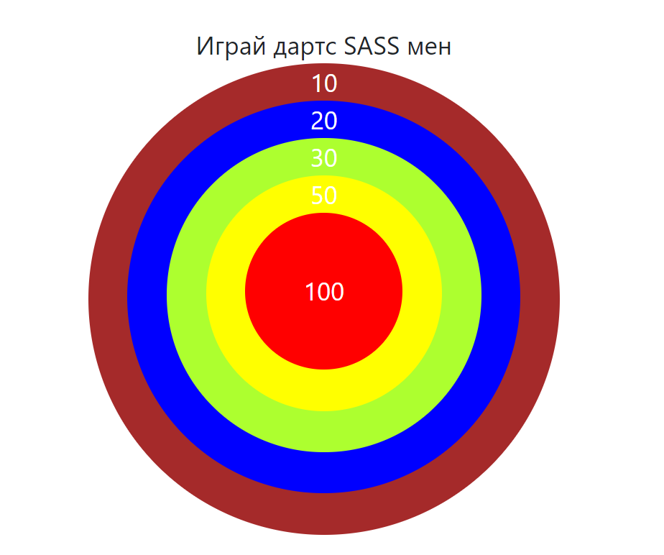

## Gradient City

Create a Web page like the picture below. Use **SASS** to achieve the desired results. You are given the **HTML file.** Use **mixins** for the gradients. Use variables to implement colors. Implement hover effect for the menu. Making the site responsive is **optional**.

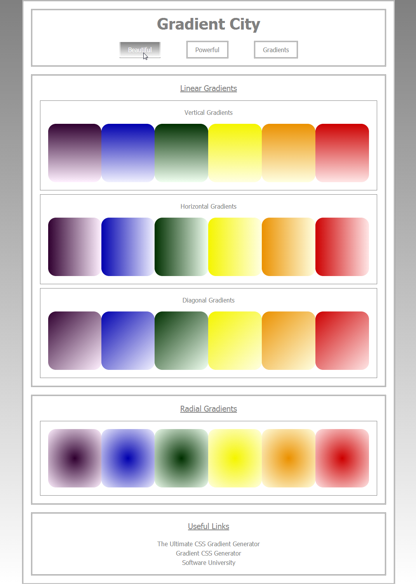

## Crazy Shaky Gallery

Using **CSS animations** create a Web page like the picture below (**100% accuracy is NOT required**).

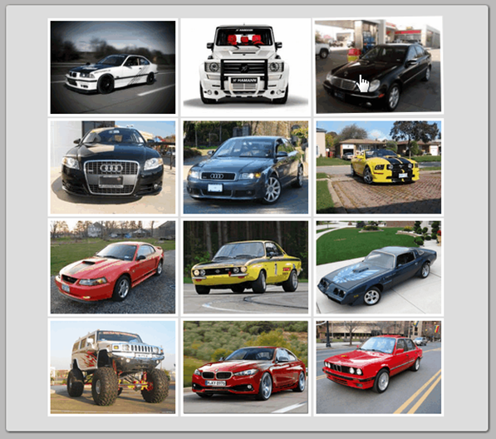 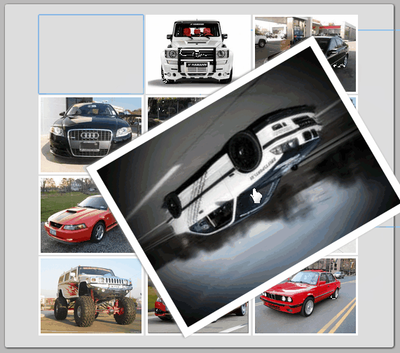

Constrains: Use **CSS3 animation and transitions** to achieve the desired results (on mouse focus and mouse hover). **Do not use the same pictures and colors**. The animations and transitions must be exactly the same as in the **GIF** file **03-CrazyShakyGallery** (open the GIF file with a browser to view the animations and transitions).